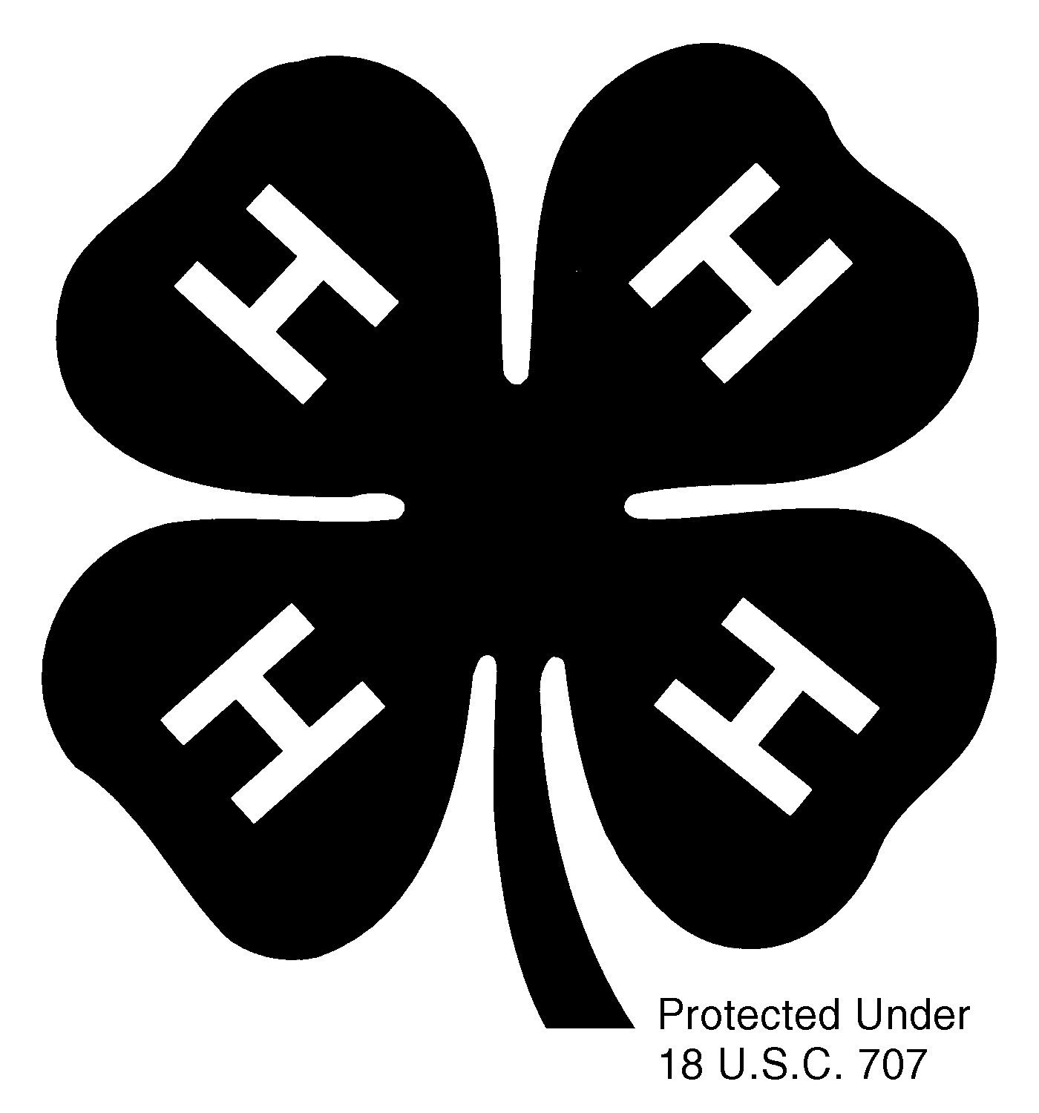
Horse Show

2009 Horse Show Exhibitor Handbook

Only information specific to state fair is listed here. For all other class requirements and procedures, refer to the “4-H Horse Contest Guide,” PNW 574.

Qualifying/Eligibility
Contestants must use the same horse in all events except for Ground Training, Driving, and Gaming. In addition, in every event, contestants must use the same horse they qualified with at their county fair.

Showmanship is required of all contestants, but you can only do showmanship once. If you have any performance horse (equitation, driving, ground training), you must show one horse in the performance showmanship class. Only gaming contestants who had no horses in performance may show in the gaming showmanship class.

Equitation and Showmanship
To qualify for State Fair in showmanship and equitation (hunt seat, saddle seat, or western), contestants must have received a minimum combined score of 170 (in equitation and showmanship) at their county fair, and each individual score must be 80 points or higher. In addition, they must have used the same horse in both classes.

For members who ride multiple seats, the highest equitation score must be used to determine eligibility. Then, if members have received blue ribbons in other seats on the same horse, they may ride those seats as well.

There is no maximum or minimum number of contestants a county may send.

Trail
Contestants who qualify for State Fair in equitation/showmanship may also enter Trail if they received a blue ribbon in that event at their county fair using the same horse as used in equitation/showmanship.

Dressage
Contestants who qualify for State Fair in equitation/showmanship may also enter Dressage if they received a score of 58% or higher on a Training Level Test 2-4 or any First Level test at their county fair using the same horse as used in equitation/showmanship.
58% and up Blue ribbon
50 – 57.99% Red ribbon
49.99% and below White ribbon
Riders may ride only one test at State Fair, and it must be the test they rode at their county fair and in which they received the qualifying score. A member who scores 62% or higher at State Fair must progress up to the next test the following year. (The requirement to move up does not apply to a new horse or in test change years.) The 2007 tests must be used.

The short arena will be used for Training Level tests and the standard arena for all First Level tests.

Hunt Seat Equitation Over Fences
Contestants who qualify for State Fair in equitation/showmanship may also enter Hunt Seat Equitation Over Fences if they received a blue ribbon in that event at their county fair using the same horse as used in equitation/showmanship and if they received the blue ribbon performing over an approved qualifying course. A qualifying course must have a minimum of six different fences with at least three of them at the maximum height and spread. There must be at least one combination jump and one change of direction.

At State Fair, a selection of warm-up fences will be provided. All contestants must be approved by the on-site official over these warm-up jumps before attempting the full course.

Driving
Contestants may only enter one driving class at the State Fair, and there are two ways to qualify.

Contestants who qualify for State Fair in equitation/showmanship may also enter driving if they received a blue ribbon in that event at their county fair using the same horse or pony as used in equitation/showmanship.

Contestants may also qualify with their non-equitation horse or pony if they received a minimum combined score of 170 (in driving and showmanship) at their county fair. In addition, the showmanship score must be 80 points or higher, and the driving score must be 85 points or higher. If contestants are not showing an equitation animal in showmanship, they must exhibit their driving animal in showmanship.

Ground Training
To qualify for State Fair in Ground Training, contestants must have received a blue ribbon in ground training at their county fair. Each county may enter one yearling and one two-year-old Ground Trainer in each age division. (The same person may show in both divisions.) If the contestant is not showing an equitation animal in showmanship, they must exhibit their ground training animal in showmanship.

Western Gaming
To qualify for State Fair in Gaming, contestants must have met the blue ribbon qualifying time in each event entered. There is no maximum or minimum number of contestants a county may send. If members are not showing another animal in showmanship, they must exhibit their gaming animal in showmanship. (There will be a showmanship class available on “gaming” day.)

2009 Oregon 4-H State Western Gaming Qualifying Times

________________________________Blue Award_______________Red Award_______White Award

Intermediate Key Race 10.700 or less 10.701-14.500 14.501 or more
Intermediate Barrels 16.600 or less 16.601-18.300 18.301 or more
Intermediate Figure 8 12.000 or less 12.001-12.900 12.901 or more
Intermediate Pole Bending 25.500 or less 25.501-28.900 28.901 or more
Intermediate NSCA Flag Race 9.300 or less 9.301-11.000 11.001 or more

Senior Key Race 10.400 or less 10.401-12.700 12.701 or more
Senior Barrels 16.200 or less 16.201-17.900 17.901 or more
Senior Figure 8 11.500 or less 11.501-12.200 12.201 or more
Senior Pole Bending 25.000 or less 25.001-28.600 28.601 or more
Senior NCSA Flag Race 9.000 or less 9.001-10.500 10.501 or more

General Information
4-H members must provide water buckets and all feed for their horses.

Box stalls will be provided. Counties will be assigned stalls according to entries. Shavings will be provided for bedding. If straw is needed, contestants will need to provide their own. Stalls must be stripped before contestants leave. Counties will be charged for any stalls left dirty.

Tack and feed stalls will be provided (one of each for up to every five horses in a county delegation).

Watchmen will patrol the barn areas at night.

No hoof polish is to be applied at the State Fair. Hoof polish that was applied before arrival at the State Fairgrounds is acceptable.

Wet mares may not be shown. Foals must be weaned at least 10 days prior to fair.

Every county is required to send an adult chaperone with the county delegation.
Chaperones must sign in at the show office, and they must have a copy of each member’s Official 4-H Health Form and Code of Conduct.

Camping sites or dorm rooms are available. For camping, refer to “State Fair Camping Rules and Reservation Instructions.” For dorm information, refer to “Participation Policies and Dormitory Rules.”

Dogs are not allowed outside of the camping area.

Arrival Procedures
Horses must arrive during the designated times. Exhibitors must have both county and state staff permission to arrive at non-designated times. All horses should be delivered to the horse barns by way of the Lana Entrance. Stall assignments will be posted at the entrance gate and at the barns. Follow instructions for parking and unloading. Park all vehicles in assigned, designated areas.

Report for mandatory registration in the Main Arena during the designated time. Contestants who do not check in during this time will not be allowed to show. Members should register in person, but in emergency situations, arrangements may be made with show management for a designee to check them in. Official 4-H Health and Code of Conduct Forms must be turned in before contestants can pick up their numbers, and numbers must be picked up in person.

Exhibitors, leaders, parents, and visitors should review all posted rules.

Check Out Procedures
Contestants may not remove their horses from the fairgrounds until they have completed showing. However, once they have completed showing, they may check out and leave at any time.

These are the steps that must be followed to check out:
- complete all classes
- strip stall
- have check out form signed by barn manager or chaperone
- pick up scoresheets at the show office (except for gaming)
- notify county chaperone that you are leaving

Oregon 4-H Horse Medallion and Medallion Ribbon Guidelines
Medallions may be awarded in each class based upon superior performance. The judges will determine whether contestants qualify for medallions, and their decisions are final.

Medallion classes may be held for Showmanship, Hunt Seat Equitation, Saddle Seat Equitation, Western Equitation and Trail. Up to 10% of the total exhibitors in a class may be brought back for the medallion class. (For showmanship, up to 10% may be brought back for each individual judge.) Medallion ribbons will be awarded to all exhibitors in the medallion class. One of the judges will orally present the pattern to the exhibitors. Judges may award medallions to no more than 5% of the total exhibitors for each class, and two of the three judges must independently agree on which exhibitors receive medallions. Movements in medallion classes can be any of those outlined in the PNW
4-H Horse Contest Guide or the Dad Potter Award Program.

At the judge’s discretion, medallions and/or medallion ribbons may be awarded in Hunt Seat Equitation Over Fences, Driving, and Ground Training. These will be awarded at the end of the class.

In Dressage, medallions may be awarded to the two highest scores in each age division at both Training Level and First Level (any test to count). The judge will determine eligibility. Ties will be broken based on Collective Marks. In addition, medallion ribbons may be awarded to the top 10% of riders at each level. The minimum score for a dressage medallion ribbon or medallion is 62% .

For each event in Gaming, the top 10% may receive a medallion ribbon. Up to 5% may receive a medallion. Medallion ribbons and medallions will be given only to blue-ribbon times.

Schedule of Events
Scheduling of 4-H Horse Show classes is subject to change.

Thursday, August 20, 2009

5:00 pm to 10:00 pm Dressage horses may arrive
7:00 pm to 8:00 pm Dressage registration

Friday, August 21, 2009

7:00 – 8:00 am Registration for Dressage continues
8:00 am to 7:00 pm Seniors and Intermediates deliver horses to barns
(All horses must be in barns by 9:00 pm)
8:00 am Dormitory opens
8:00 am Dressage Orientation Meeting
8:30 am Dressage First Level begins in Outside Arena
Followed by: Dressage Training Level in Outside Arena
4:00 pm to 7:00 pm Seniors and Intermediates register at office (mandatory)
7:00 pm Orientation meeting in the Main Arena

Saturday, August 22, 2009

8:00 am Horse Presentations, Dairy Show Green
8:00 am Intermediate Ground Training in Main Arena
Senior Ground Training in Outside Arena
Followed by: Intermediate Showmanship in Main Arena
Senior Showmanship in Outside Arena
Followed by: Medallion classes for Intermediate and Senior
Showmanship in the Main Arena
Followed by: Hunt Seat Equitation Over Fences (Intermediate and Senior) in the Outside Arena

Sunday, August 23, 2009

8:30 am Senior Hunt Seat Equitation in Main Arena
Intermediate Hunt Seat Equitation in Outside Arena
Followed by: Senior Saddle Seat Equitation in Main Arena
Intermediate Saddle Seat Equitation in Outside Arena
Followed by: Medallion classes for Senior and
Intermediate English Equitation in Main Arena
Followed by: Intermediate and Senior Driving in the Main Arena
All day Trail Horse (Intermediate and Senior) in the Outside Arena

Monday, August 24, 2009

8:30 am to 2:00 pm Trail Horse (Intermediate and Senior) in the Outside Arena
8:30 am Senior Western Equitation in the Main Arena
Intermediate Western Equitation in the Outside Arena
Followed by Medallion classes for Senior and Intermediate Western
Equitation and Trail in the Main Arena
Followed by: Medallion classes for Senior and Intermediate Trail
5:00 pm Contestants should have cleaned stalls and checked out
5:00 pm Gaming contestants begin to deliver horses to barns
5:00 to 8:00 pm Contestants register for gaming

Tuesday, August 25, 2009

7:00 to 7:30 am Contestants register for gaming (continued)
7:30 am Gaming Orientation Meeting in Main Arena
8:30 am Gaming Senior Showmanship in Outside Arena
Gaming Intermediate Showmanship in Outside Arena
10:30 am Gaming begins in Main Arena
Senior Figure 8
Intermediate Figure 8
Senior Key Race
Intermediate Key Race
Senior Pole Bending
Intermediate Pole Bending
Senior Flags
Intermediate Flags
Senior Barrels
Intermediate Barrels
9:00 pm All stalls must be stripped and horses gone

Class Entries

Please read eligibility requirements for each class.

Horse Showmanship (Required; select gaming showmanship only if you have not done performance showmanship)
751 500 002 Intermediate Performance Showmanship
751 500 003 Senior Performance Showmanship
751 500 012 Intermediate Gaming Showmanship
751 500 013 Senior Gaming Showmanship

Equitation
751 100 112 Intermediate Saddle Seat Equitation
751 100 113 Senior Saddle Seat Equitation
751 100 122 Intermediate Hunt Seat Equitation
751 100 123 Senior Hunt Seat Equitation
751 100 132 Intermediate Western Equitation
751 100 133 Senior Western Equitation

Trail Horse
751 100 312 Intermediate Trail Horse
751 100 313 Senior Trail Horse

Hunt Seat Equitation Over Fences
751 100 162 Intermediate Hunt Seat Equitation Over Fences
751 100 163 Senior Hunt Seat Equitation Over Fences

Ground Training
751 100 212 Intermediate Yearlings
751 100 213 Senior Yearlings
751 100 222 Intermediate Two-Year-Olds
751 100 223 Senior Two-Year Olds

Driving
751 100 412 Intermediate Pony Driving
751 100 413 Senior Pony Driving
751 100 422 Intermediate Horse Driving
751 100 423 Senior Horse Driving

Dressage
751 100 512 Intermediate Dressage – Training Level, Test 2
751 100 513 Senior Dressage – Training Level, Test 2
751 100 522 Intermediate Dressage – Training Level, Test3
751 100 523 Senior Dressage – Training Level, Test 3
751 100 532 Intermediate Dressage – Training Level, Test 4
751 100 533 Senior Dressage – Training Level, Test 4
751 100 542 Intermediate Dressage – First Level, Test 1
751 100 543 Senior Dressage – First Level, Test 1
751 100 552 Intermediate Dressage – First Level, Test 2
751 100 553 Senior Dressage – First Level, Test 2
751 100 562 Intermediate Dressage – First Level, Test 3
751 100 563 Senior Dressage – First Level, Test 3
751 100 572 Intermediate Dressage – First Level, Test 4
751 100 573 Senior Dressage – First Level, Test 4

Gaming
751 800 012 Intermediate Figure 8
751 800 013 Senior Figure 8
751 800 032 Intermediate Key Race
751 800 033 Senior Key Race
751 800 042 Intermediate Pole Bending
751 800 043 Senior Pole Bending
751 800 052 Intermediate NSCA Flag Race
751 800 053 Senior NSCA Flag Race
751 800 022 Intermediate Barrels
751 800 023 Senior Barrels

